PYTHON PROGRAMING

DAY-1

PARTHASARATHY.A(192211244)

1. Given two strings “s” and “t”, determine if they are isomorphic. Two strings “s” and “t” are isomorphic if the characters in “s” can be replaced to get “t”. All occurrences of a character must be replaced with another character while preserving the order of characters. No two characters may map to the same character, but a character may map to itself.

Constraints

• s and t consist of any valid ascii character.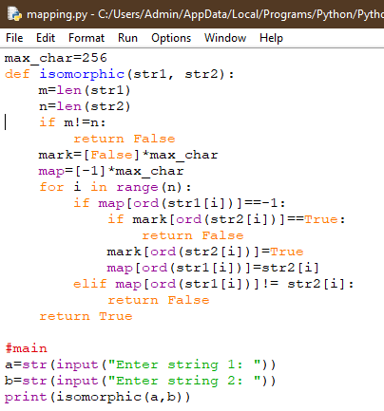

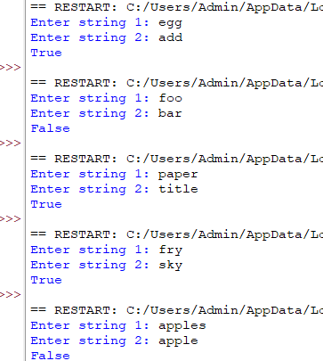

2. Write a Python function sumsquare(l) that takes a nonempty list of integers and returns a list [odd,even], where odd is the sum of squares of all the odd numbers in l and even is the sum of squares of all the even numbers in l.

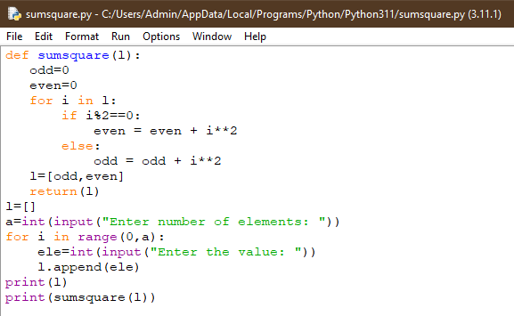

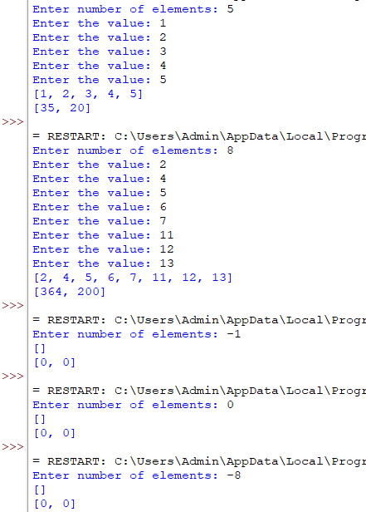

3. Write an algorithm to determine if a number n is happy. A happy number is a number defined by the following process:

• Starting with any positive integer, replace the number by the sum of the squares of its digits.

• Repeat the process until the number equals 1 (where it will stay), or it loops endlessly in a cycle which does not include 1.

• Those numbers for which this process ends in 1 are happy. Return true if n is a happy number, and false if not.

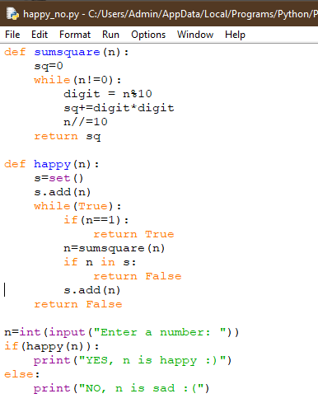

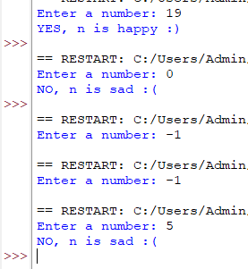

4. Given an integer x, return true if x is palindrome integer.

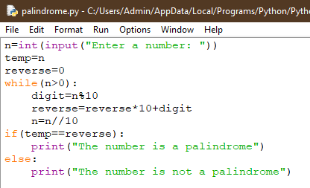

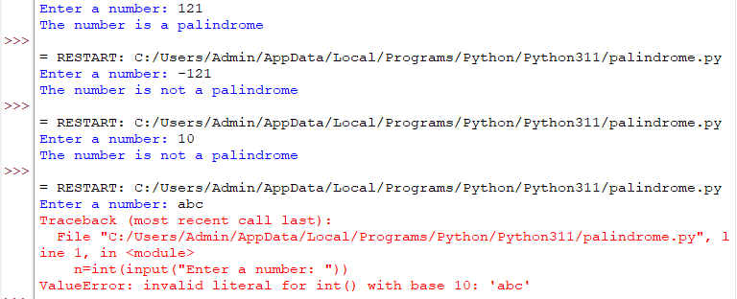



5. A bakery sells loaves of bread for 185 rupees each. Day old bread is discounted by 60 percent. Write a program that begins by reading the number of loaves of day old bread being purchased from the user. Then your program should display the regular price for the bread, the discount because it is a day old, and the total price. All of the values should be displayed using two decimal places, and the decimal points in all of the numbers should be aligned when reasonable values are entered by the user.

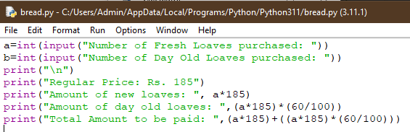

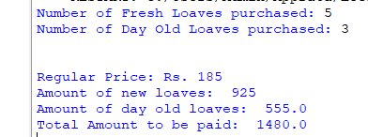

6. Given n non-negative integers a1,a2,a3,...an where each represents a point at coordinate (i,ai) . „ n „ vertical lines are drawn such that the two endpoints of line i is at (i, ai) and (i,0). Find two lines, which together with x-axis forms a container, such that the container contains the most water. The program should return an integer which corresponds to the maximum area of water that can be contained (maximum area instead of maximum volume sounds weird but this is the 2D plane we are working with for simplicity).

Note: You may not slant the container.

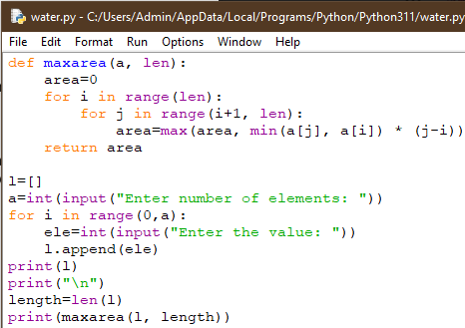

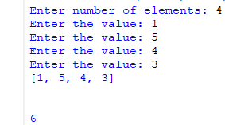

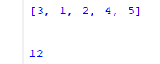

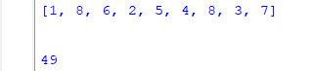

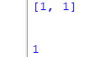

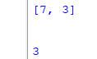

7. Given an integer n, return the number of strings of length n that consist only of vowels (a, e, i, o, u) and are lexicographically sorted. A string s is lexicographically sorted if for all valid i, s[i] is the same as or comes before s[i+1] in the alphabet.

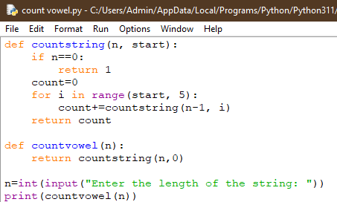

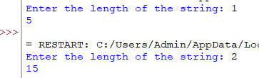

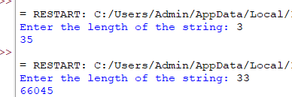



8. A valid number can be split up into these components (in order):

1. A decimal number or an integer.

2. (Optional) An 'e' or 'E', followed by an integer.

A decimal number can be split up into these components (in order):

1. (Optional) A sign character (either '+' or '-').

2. One of the following formats:

1. One or more digits, followed by a dot '.'.

2. One or more digits, followed by a dot '.', followed by one or more digits.

3. A dot '.', followed by one or more digits.

An integer can be split up into these components (in order):

1. (Optional) A sign character (either '+' or '-').

2. One or more digits.

For example, all the following are valid numbers: ["2", "0089", "-0.1", "+3.14", "4.", "-.9", "2e10", "-90E3", "3e+7", "+6e-1", "53.5e93", "-123.456e789"], while the following are not valid numbers: ["abc", "1a", "1e", "e3", "99e2.5", "--6", "-+3" "95a54e53"]. Given a string s, return true if s is a valid number.

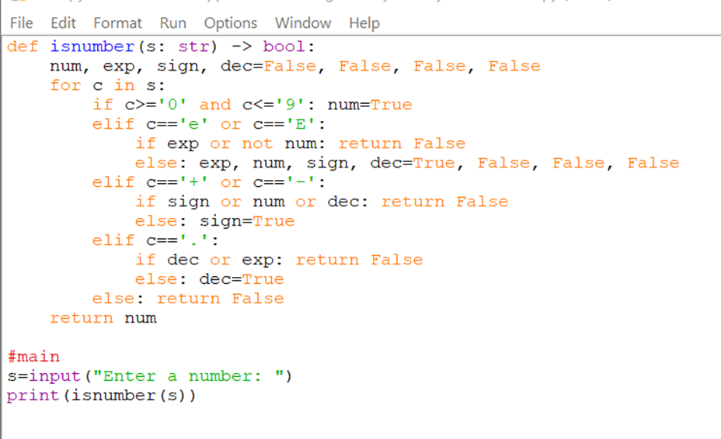

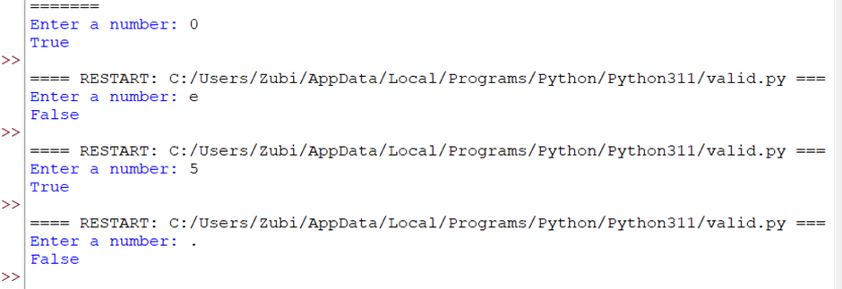

9. A party has been organised on a cruise. The party is organised for a limited time (T). The number of guests entering (E[i]) and leaving (L[i]) the party at every hour is represented as elements of the array. The task is to find the maximum number of guests present on the cruise at any given instance within T hours.

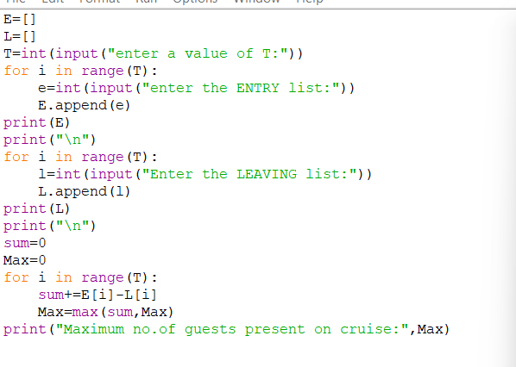

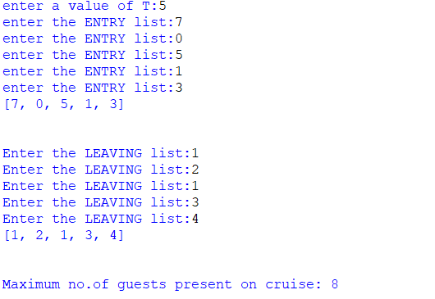

10.Modify string by replacing characters by alphabets whose distance from that character is equal to its frequency Given a string S consisting of N lowercase alphabets, the task is to modify the string S by replacing each character with the alphabet whose circular distance from the character is equal to the frequency of the character in S.

